Chapter 1

Introduction

A lot of DDoS attack is happening in the world of networking. SYN flooding is one of the primary and significant one which is basically flooding the server with SYN packets. At the same time we have real time switches coming up, which can be controlled from a remote host to control traffic and analyze the network packets. One such switch is a server switch by Pluribus Networks Company.
Our project basically uses both these information and aims at detecting and preventing these kinds of attack that’s happening in the field of networking. With the help of Pluribus Network Switch, certain commands are run in the switch remotely using Pluribus Netvisor Command Line Interface and the data is retrieved. This data is analyzed to check for possible DDoS attack and if it is found to be such a case then further prevention techniques are used where the IP address that is causing this attack is blocked and an e-mail is sent to the switch admin regarding the same.
We make use of different OS functions available in Python-language to connect to a remotely available server switch and other techniques like pipe execution of shell commands to run commands in the switch.

Chapter 2

Motivation and Aim

The primary cause of DDoS attack is SYN flood attack which is performed by sending a lot of SYN flood. This is a basic kind of attack which will still put down the server thus preventing server from communicating with its clients.
Even though there are many software which prevents DDoS attack these software will have to be installed in each of the client system, just like antivirus software running all the type in client system. Thus in a huge network of computer all the client and servers will have to be running such software to prevent DDoS attack which will create a lot of overhead.
Our project on the other hand need not have to run in all host or end-systems. Rather this will be running in the network link where the packets should pass during its journey from any client to any server. So a lot of overhead on each end-system is prevent and they can concentrate on reliable data transfer rather than concentrating on security.
We make use of a real time switch in which we run this software which runs commands in the switch retrieves data from the switch and analyses the data to check for attack and takes action.

Chapter 3

Literature review

  - Planes in Telecom Architecture
There are 3 main planes in all traditional router, Data plane, Control plane, Management Plane.
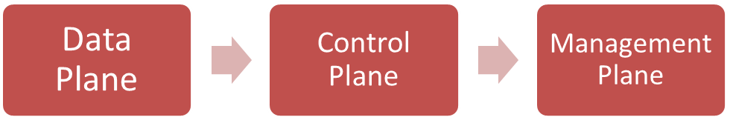
3.1.1 Control Plane
The control plane is primarily about the learning of routes. Control plane is the part of the router architecture that is concerned with drawing the network map, or the information in a routing table that defines what to do with incoming packets.
3.1.2 Data Plane
Actually moving the packets based on what we learned. The data plane (sometimes known as the user plane, forwarding plane, carrier plane or bearer plane) is the part of a network that carries user traffic. The data plane enables data transfer to and from clients, handling multiple conversations through multiple protocols, and manages conversations with remote peers. Data plane traffic travels through routers, rather than to or from them.

3.2 Software Defined Networking
In conventional networking, all three planes are implemented in the firmware of routers and switches.
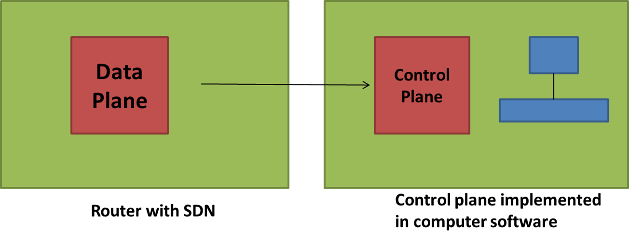
SDN decouples the data and control planes and implements the control plane in software instead, which enables programmatic access to make network administration much more flexible.
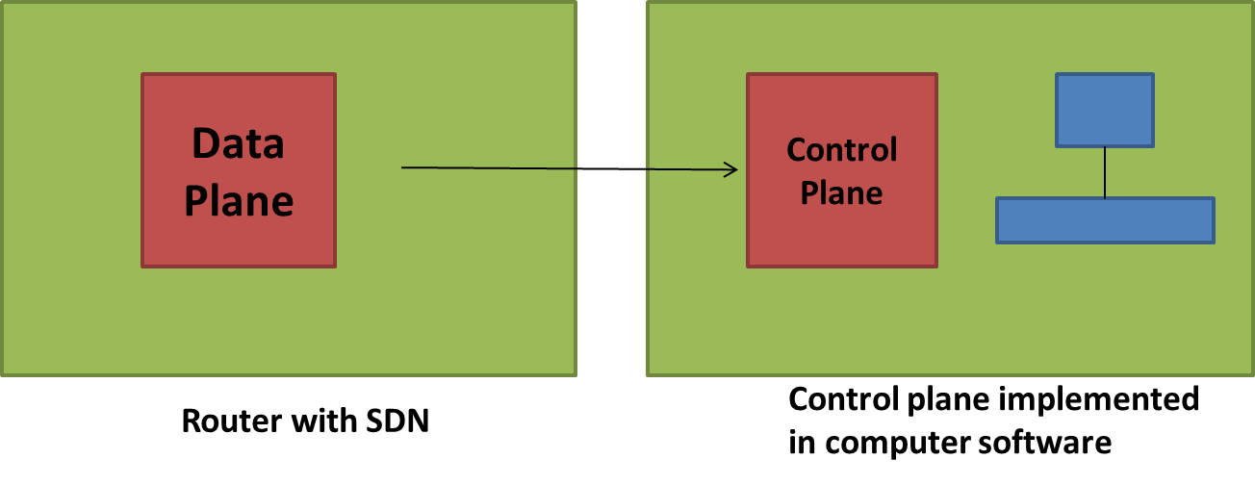
3.2.1 Advantage of SDN
Dynamic access and administration. A network administrator can shape traffic from a centralized control console without having to touch individual switches. The administrator can change any network switch's rules when necessary -- prioritizing, de-prioritizing or even blocking specific types of packets and IP and thus prevent users from attacking network.

  - Pluribus Switch
3.3.1 What is Pluribus Switch?
A server switch by Pluribus Networks which employs SDN technology. It has its own Pluribus Netvisor Analytics Engine which runs in it(OS), which allows user to view all the packet and other network related information. These switches have its own, Memory, RAM, Processor chip and other components of Traditional switch.
    - Pluribus Netvisor Analytics Engine
With help of this following data will be available to users - Port information, Network topology, Traffic information, Individual packet data, Overall packets and their details
3.3.3 Pluribus Switch Command Line Interface
The Netvisor Command Line Interface (CLI) provides powerful analytical commands to retrieve data from switch and all data is also available to Netvisor APIs.
Examples
  - ‘connection-show’
    - display all connections across the fabric
  - ‘client-server-stats-show’
    - a summary per IP address
  - Vflow
    - to disable a communication

3.4 Distributed Denial of Service-DDoS
3.4.1 DDoS Introduction
In computing distributed denial-of-service (DDoS) attack is an attempt to make a machine or network resource unavailable to its intended users. Types are Internet Control Message Protocol (ICMP) flood, SYN flood, Teardrop attacks, Peer-to-peer attacks, Application-level floods, HTTP POST DDOS attack.
    - SYN flood
3.4.2.1 Normal TCP 3-Way Hand shake
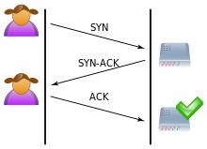
User
Server

All 3 parts, i.e. sending SYN by user and sending SYN-ACK by server followed by ACK by user is followed to create a proper TCP connection.

      - TCP connection during attack scenario
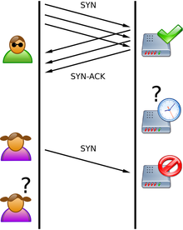
User sends
But doesn’t send
acknowledgement
Server under
attack

Server tries to
Handle all SYN and
Gets clogged

User resends
SYN repeatedly

Only the first 2 parts, i.e. sending SYN by user and sending SYN-ACK by server is followed but the user doesn’t send ACK to server, the user then repeats this process continuously to clog the server and thus attacking the server.

Chapter 4
Design

4.1 DDoS Detection technique
The software does following at regular interval of 5 seconds : Connect to the switch - using ssh, username and password, Retrieve data of packets for each client-server pair along with their SYN count - run ‘client-server-stats-show’ command in the switch cli and analyze the whole data retrieved to see all those tuples for which SYN count is greater than 1000 and return all those client-IP addresses – input the data and scan and check for syn_count>1000

  - DDoS Prevention technique
The detection algorithm is run at every 5 seconds and it returns a set of IP addresses which try to do a SYN flood DDoS attack.
For each of those IP addresses, The pluribus netvisor’s ‘vflow’ command is used and IP’s are blocked from communication thus preventing any further SYN flood happening and an e-mail is set to the switch admin regarding this, so that he can take any further action required.

4.3 Program Flow
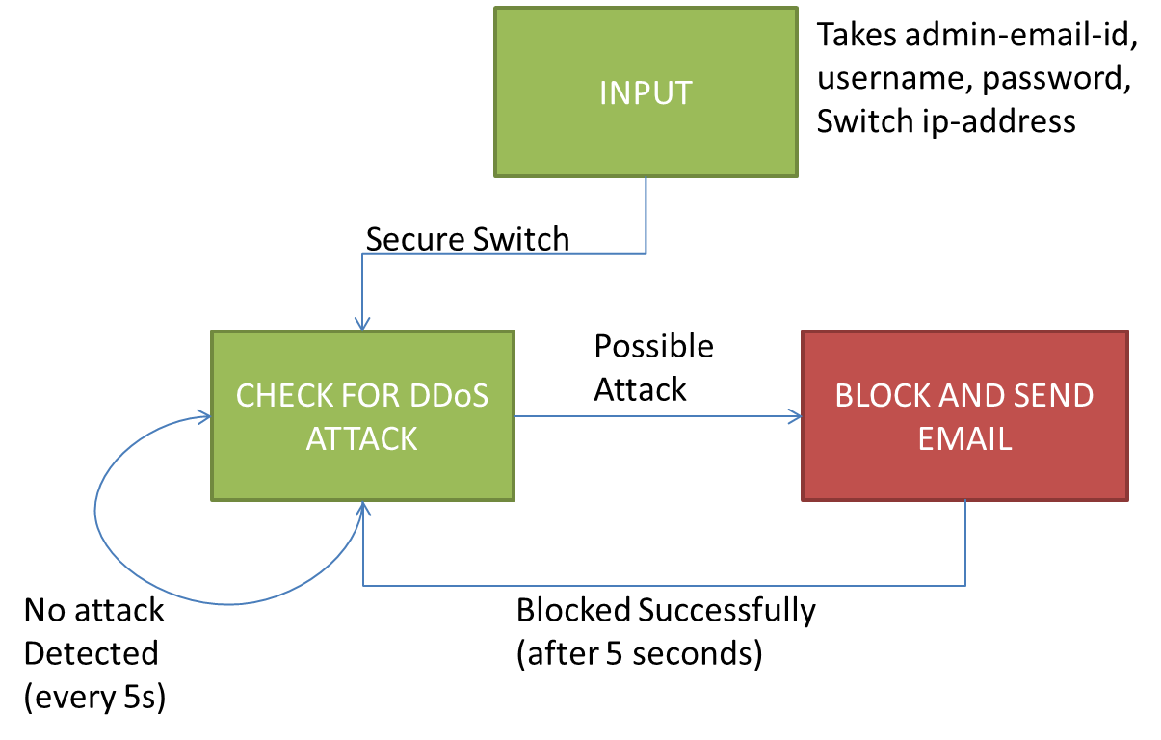
Initially user is asked to input his E-mail ID, along with that he has to enter the switch details, i.e. switch IP address, its username and password. After entering the details and he has to press ‘Secure Switch’ button on which he is taken to a state of forever checking state. In this state the program always checks for DDoS attack and if there is no attack then it re-checks for attack after 5 seconds. Otherwise if an attack is detected then it goes to a state where the corresponding IP address is blocked and an email is sent to the Switch admin email ID. The checking process then continues after 5 seconds the whole process continues.

  - Pseudo Code
    - Pseudo Code for Connection to Switch
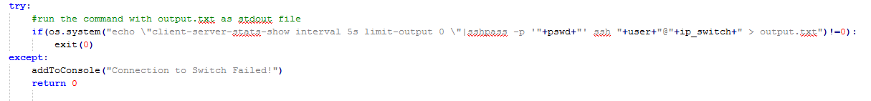
Python os module is used for connection purpose as it will be helpful in doing a ssh and connecting to a remote server. Os.system function which runs commands in the Ubuntu shell terminal is used to do an ssh to the switch and connect to it. Terminals pipe execution of commands, i.e. writing more than one command in a single line and executing both one after the other is used to first connect to the switch and then execute the switch’s command in it. On invalid or other failure proper error messages are displayed by handling them.

    - Pseudo Code for Data Retrieval and Detection

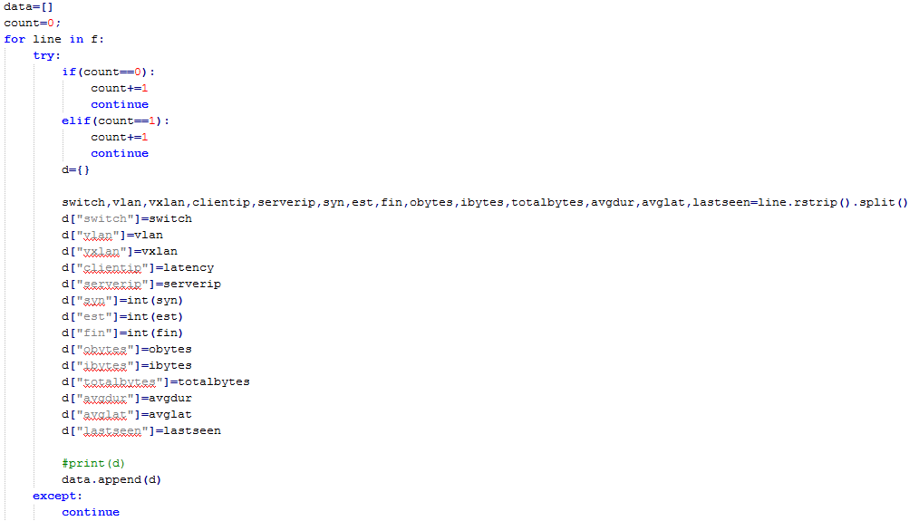

Data Structure like dictionary is used to store the output obtained from the switch command line. Each of the row data is retrieved from the file where the output is stored and put into the dictionary which can used further for analyzing the data. This is done for all the rows in the output data and stored in the dictionary with their appropriate column names.
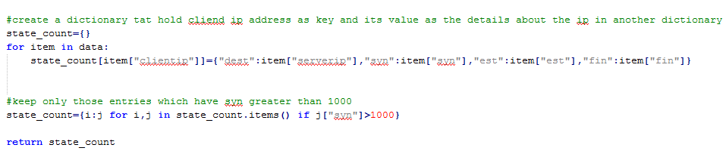
The dictionary of data is traversed all the way till the end to check for presence of attack. For each value in dictionary, the SYN count for each client-server tuple is checked. If its greater than 1000 then a possible DDoS attack is suspected and those IP are added to a list data structure which can be used to take further action for preventing the attack.
    - Pseudo Code for Prevention

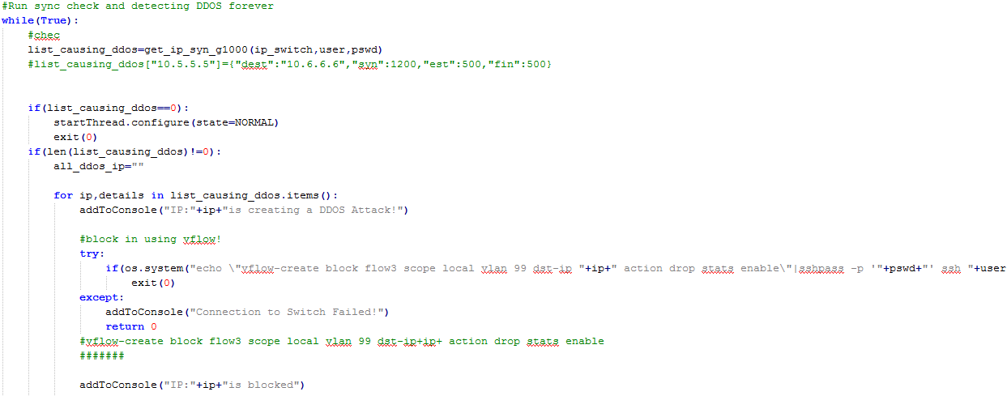
After retrieving all IP addresses that are possibly causing attack for each of the IP address vFlow command is used to block those IP address from further communication and thus preventing the attack. VFlow command is run for each of the IP address in the list.

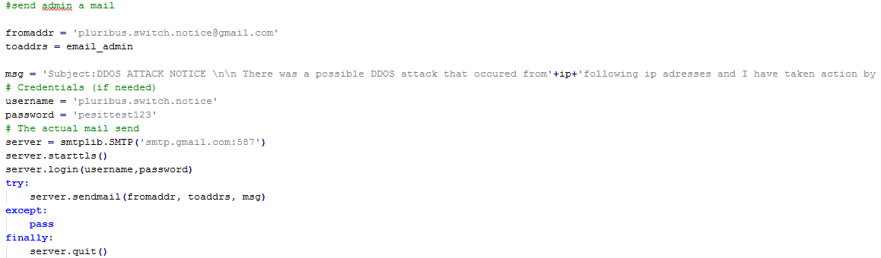
The Admin of the switch should be notified regarding this as he might want of unblock the IP address if he was creating the attack for some practical purpose. Thus an email is sent to the email-ID of the admin and all the IP-addresses are attached with the email.

Chapter 5

Conclusions and Future Work

This can be further applied to detect ICMP flood scenarios which is one more type of DDoS attack. IP spoofing detection algorithm can be incorporated with this program thus able to detect users who try to create an attack by spoofing their IP. By adding all other types of DDoS attack detection techniques, the same software will be able to use with better features added thus making it scalable.
Machine Learning models can be used to further predict attacks even before they actually occur and thus prevent the possibility of the attack as well.

Chapter 6
Snapshots

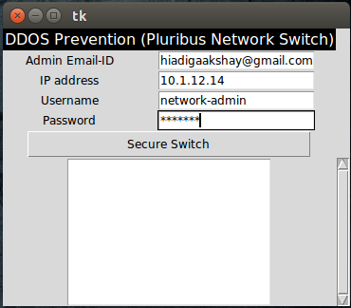
Fig 1. Initially it asks for Admin Email-ID, Switch IP-address, Switch Username and Switch Password

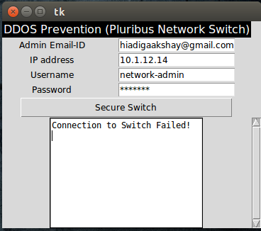
Fig 2. On wrong username and password

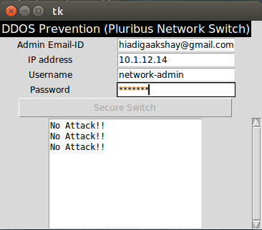
Fig 3. On clicking ‘Secure Switch’ button

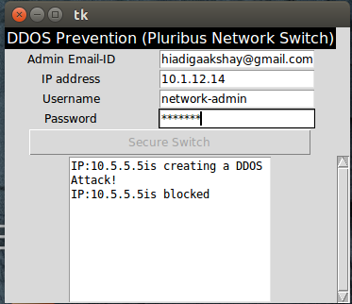
Fig 4. When an attack is detected the IP is first blocked

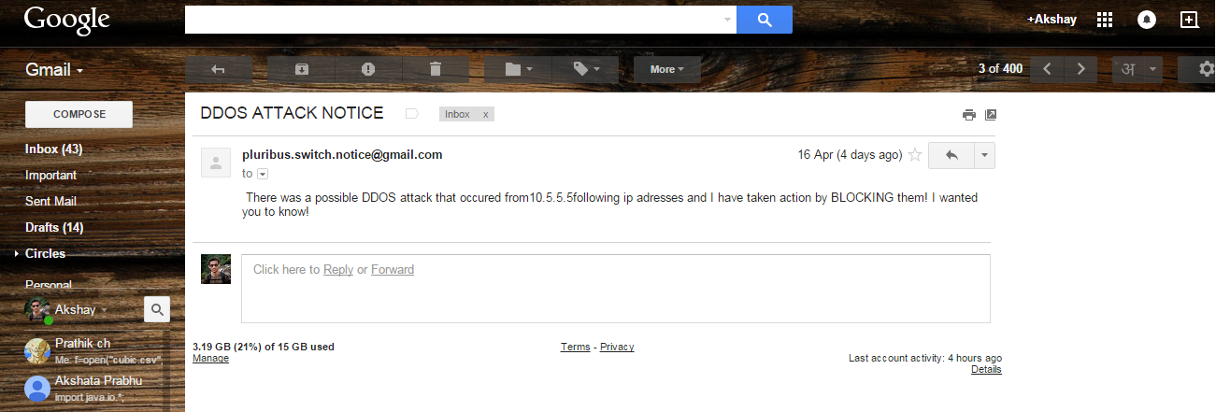
Fig 5. A mail is sent to the Switch Admin regarding the same

References

[1] Pluribus Switch Working and Basics - PN-WP-analytics-2-0.pdf
[2] Command Line Interface for Pluribus Switch - pocket-guide-vflows-v22.pdf
[3] How SYN flood happens in real - http://en.wikipedia.org/wiki/SYN_flood

